**Box Hill Community Arts Centre**

**Exhibition Expression of Interest 2024**

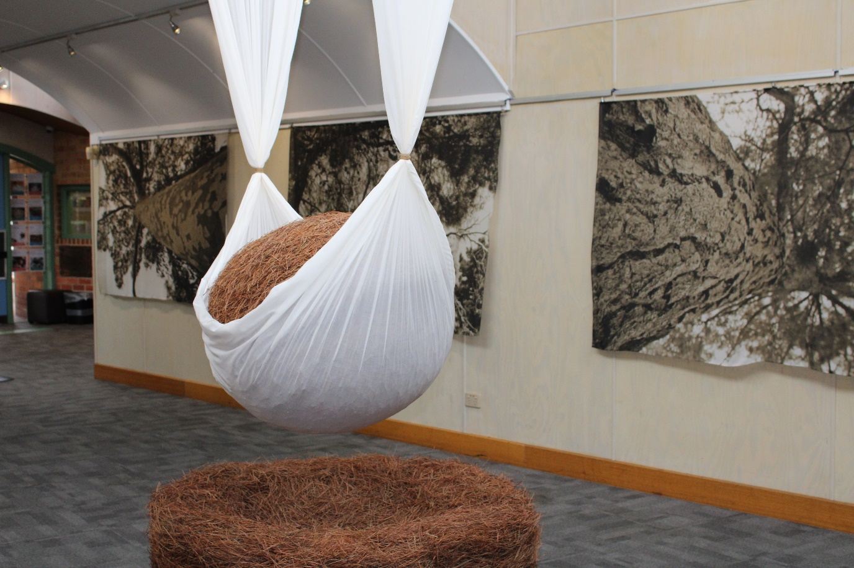

Artist in Residence Program - Marynes Avila - Oasis - April 2022

Box Hill Community Arts Centre (BHCAC) is an artistic and cultural hub located within Box Hill, Victoria, Australia and operated by Whitehorse City Council.

Home to a wide variety of local arts and community groups, the Centre is a meeting place where people from all walks of life can come together to experience and enjoy art. The gallery is open Monday – Friday during office hours and admission is free. Weekend gallery hours vary. The Alcove Art Shop, adjacent to the gallery, is able to handle sales from exhibitions.

**BHCAC invites applications from artists to exhibit  
within our professional public gallery in 2024.**

**Please complete and return the attached form or visit** [**www.bhcac.com.au**](http://www.bhcac.com.au) **to submit an electronic application.**

**BHCAC encourages exhibitions that:**

* Promote and support traditional and contemporary art forms
* Explore new ideas and techniques
* Support emerging artists
* Showcase the practice of both mid-career and established artists
* Tell a story, relate a message and encourage conversations around  
  current social community issues
* Promote social inclusion and cultural diversity
* Support local, state and interstate artists

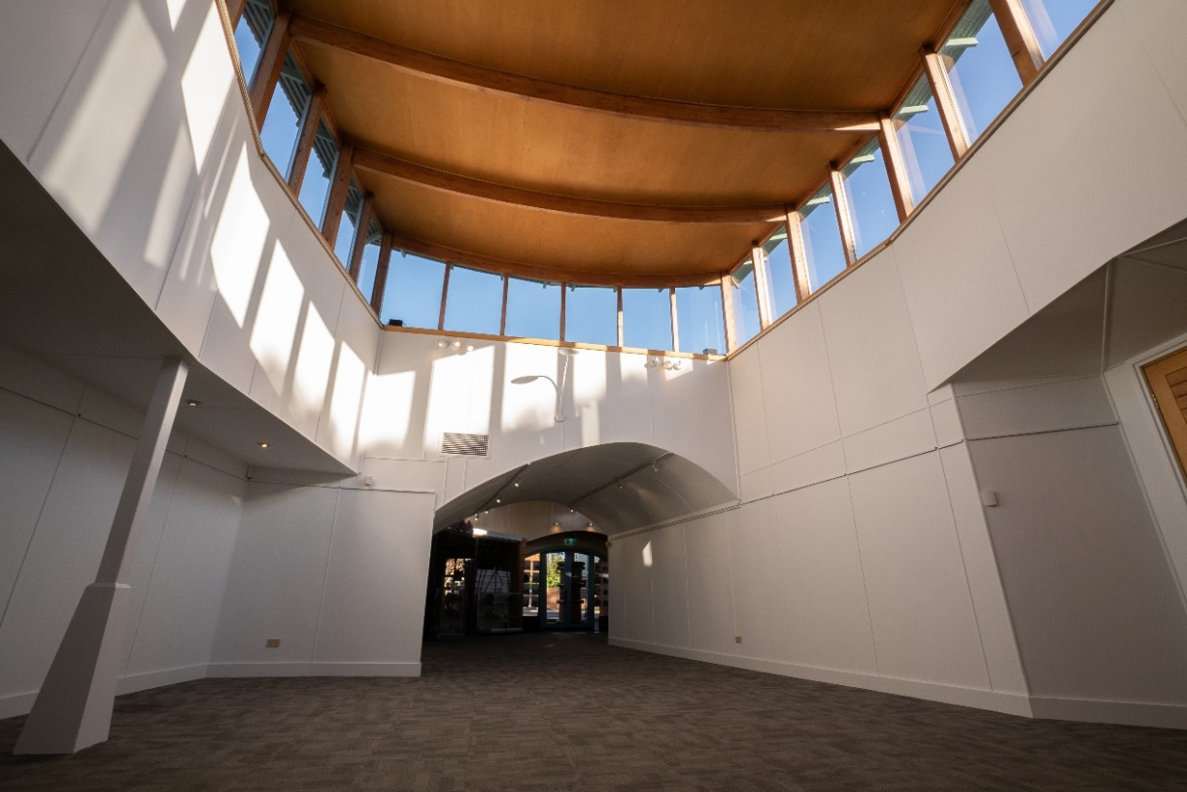

**Gallery Dimensions**

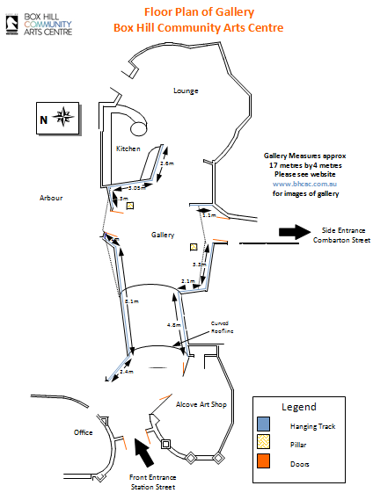

Gallery measures approx. 17 metres by 4 metres.

Please see website for images of gallery

**Gallery Hire Costs**

All exhibition bookings are for three weeks. Hire cost of the gallery is $1400 per three weeks ($475 per week) (GST inclusive). The hire fee includes a two-hour exhibition opening in the lounge/kitchen (time and date subject to availability). Fee includes design and printing of 30 invitations (extra copies can be organised on request at an additional cost).

Bookings cancelled with less than one months’ notice will be invoiced for the full cost of the exhibition.

**Exhibition Package - Hire of the gallery includes access to the following:**

• Installation guidance, if required

• A variety of plinths

• Five glass display cabinets of varying sizes

• Hanging tracks, wires and hooks, magnetic hanging system for works on paper

• Design and printing of 30 exhibition invitations

• Lounge/kitchen area for use on opening night, equipped with:

* + Café style seating and tables for approximately 40 people (subject to covid density limits)
  + Microwave, oven, fridge, crockery
  + Open fireplace
  + Small PA system and a TV/DVD/Video.

**Promotion**

As part of the exhibition package, BHCAC will promote through the following channels:

• Whitehorse News (Whitehorse City Council’s monthly newspaper)

• Creative Whitehorse digital channels: website, eNews inclusions, Facebook and Instagram

• Art publications, including Art Almanac and Arts Hub

• A variety of free public listing media.

**Exhibitors must fulfil the following responsibilities:**

• Adhere to BHCAC’s Conditions of Hire, which will be provided upon request or at the time of being offered an exhibition.

• Set up on a Monday after 10am. Pack up on a Sunday or Monday morning before 10am.

• Provide insurance to cover damage or theft of artworks on display or in transit to and from BHCAC

• Provide public liability insurance to cover you and/or members of your group while undertaking activities within BHCAC. A certificate of currency must be provided.

• Deliver, hang and/or assemble the exhibition on the arranged dates/times, ensuring that no changes are made to fixed structures (no nails, hooks, stickers etc. are to be used). Costs related to repairing any damage will be charged to the exhibitor. **Works to be hung at the highest level in the gallery will incur an extra cost for the hire of a scissor lift, which must be organised prior to exhibition set up.**

• Accept that invitations must be designed in-house by BHCAC.

• Provide a media release and print quality digital images on confirmation of your exhibition to assist with promotion.

• Provide a catalogue of items to be exhibited, including name of work, name of artist, medium, sale price and any other relevant details prior to exhibition set up.

• Produce labels for artworks using BHCAC template.

• Ensure any items sold remain on display for the duration of the exhibition.

• Supervision of the exhibition is the responsibility of the exhibitor during operating hours, unless arrangements are made with the Alcove Art Shop – BHCAC takes no responsibility for work left unattended.

• Negotiate with BHCAC staff regarding opening event dates and times (no Friday or Saturday nights).

• Provide all food and beverages for the exhibition opening.

• Ensure the gallery and lounge/kitchen area are left in a clean and tidy state after exhibition opening.

• Dismantle the exhibition on due date and time and ensure gallery is clean and restored to its original condition.

• Return all equipment used to the BHCAC office.

**Management reserves the right to:**

* + - Refuse to display work that they deem to be offensive
    - Refuse to display work that is deemed unsuitable to display due to health and safety reasons
* Refuse to allow work to be hung at the highest level in the gallery without the hire of a scissor lift.
  + - Make final curatorial decisions on all exhibitions.



**Box Hill Community Arts Centre**

**Exhibition Expression of Interest Form**



**Privacy Notification -** Personal information requested such as name and address, is collected for the purpose of registering and administering applications for hiring council facilities. The personal information collected will not be used for any other purpose or disclosed except as may be required by law. If you do not provide the information then your application may not be processed. You may access the information collected about you by contacting the BHCAC Centre Coordinator on 9895 8888.

**All information must be completed to be considered. Visit** [**www.bhcac.com.au**](http://www.bhcac.com.au) **to submit an electronic application.**

**Contact Details:**

Name of Organisation / Individual: _________________________________________________

Primary Contact Person: ________________________________________________________

Postal address: _______________________________________________________________

Email: _______________________________________________________________________

Website: _____________________________________________________________________

Phone Number: _______________________________________________________________

|  |  |  |
| --- | --- | --- |
|  |  |  |

**Exhibition Details:**

Title of Exhibition:______________________________________________________________  
Number of artists exhibiting work: _________________________________________________

Preferred month: ______________________________________________________________

Website (or email 3 images): _____________________________________________________  
Type of artwork to be exhibited (theme, style, medium): ________________________________

______________________________________­­­­­­­­­­­­­­______________________________________

**Please note:**

Completing this form does not guarantee an exhibition. Applications will be prioritised according to two main criteria:

* Strong evidence the exhibition is aligned with Whitehorse City Council’s Art and Cultural Strategy.
* Meets the Curatorial needs for the current year in regard to variety, diversity, and quality as well as any specific themes as determined by BHCAC.

**Please return to:**

Box Hill Community Arts Centre470 Station Street, Box Hill VIC 3128.

Email: [bhcac@whitehorse.vic.gov.au](mailto:bhcac@whitehorse.vic.gov.au)  
­­­­­­­­­­­­­­­­­­­